Name : Mohd Usama
Assignment :: PHP 7 and Design patterns

Q1:- Upgrade PHP version to PHP 7.4
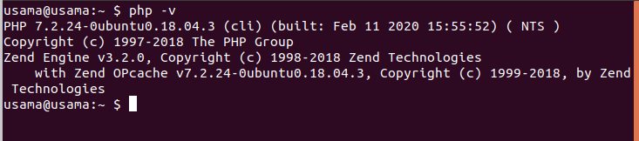

Q2:- What are the advantages of spread operator over array_merge in PHP?

Ans:- Advantages of spread operator over array_merge
It's because not only that spread operator is a language structure while array_merge is a function call, but also compile time optimization can be performant for constant arrays. array_merge only supports array, while spread operator also supports objects implementing Traversable

Q3:- Write the output of these;
$arr1 = [1, 2, 3];
$arr2 = [...$arr1];
$arr3 = [0, ...$arr1];
$arr4 = array(...$arr1, ...$arr2, 111);
what will be the output of $arr2, $arr3, $arr4.

Ans :

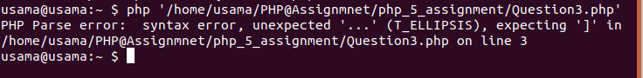

Q4:- Write a program to print an array in which output is returned by function using the spread operator.

Ans :
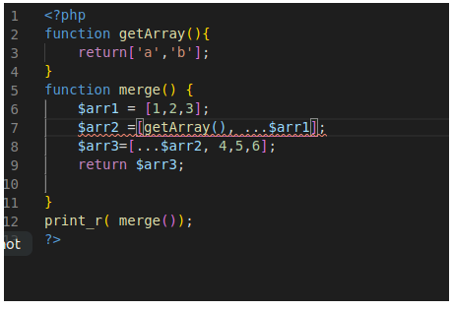

Q5:- What is dependency Injection?

Ans:- Dependency injection is a procedure where one object supplies the dependencies of another object. Dependency Injection is a software design approach that allows avoiding hard-coding dependencies and makes it possible to change the dependencies both at runtime and compile time.

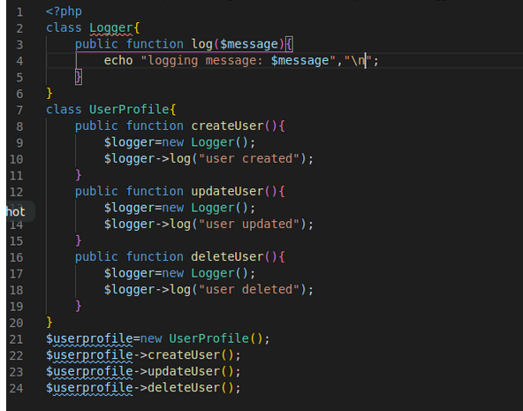
Output::
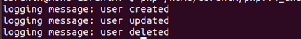

Q6:- Write an example of a factory class where we pass 4 different car models and it returns price and builds the year of the car.
Ans :
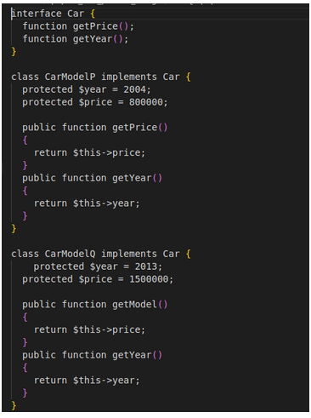

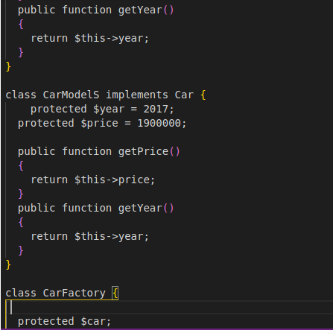
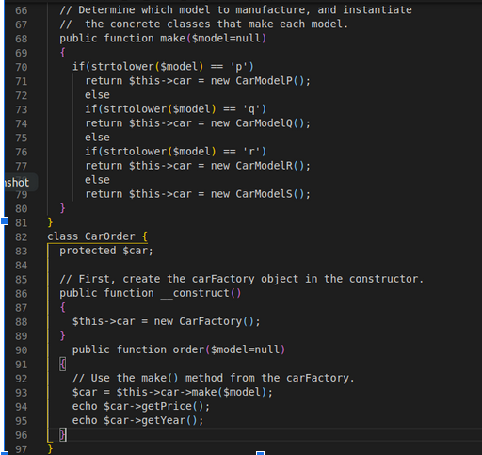

Q7:- Give an example of singleton class.

Ans:- Singleton class which is instantiated only once.

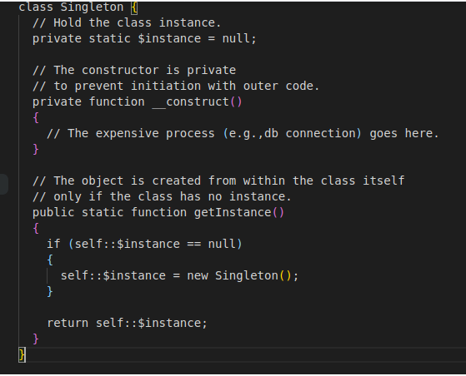

Q8:- What are the benefits of following design patterns?

Ans:-Design patterns have two major benefits. First, they provide you with a way to solve issues related to software development using a proven solution. The solution facilitates the development of highly cohesive modules with minimal coupling. They isolate the variability that may exist in the system requirements, making the overall system easier to understand and maintain. Second, design patterns make communication between designers more efficient. Software professionals can immediately picture the high-level design in their heads when they refer to the name of the pattern used to solve a particular issue when discussing system design.

Q9:-Define a class with type properties.
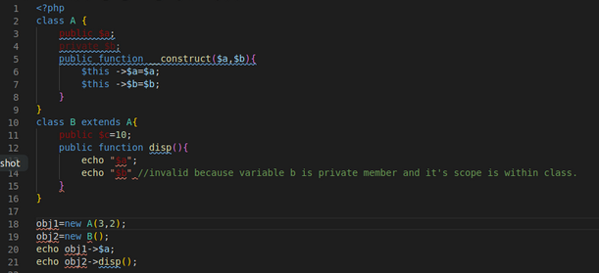

Q10:- Write a function using arrow function array_map.

Ans :
